Appendix C: Java Kitchen Application - Interface Specification

The Java Kitchen Application (JKA), jointly developed by the Royal St.Kitts Association of Liquid Food Controllers (RASKAL) and Java Kitchen Management Applications Inc., aims to supports the tasks of liquid food controllers, i.e. the management of liquid food substances. JKA is a state of the art application that is created using the latest standards in GUI programming. This user-friendly application supports the activities of the Liquid Food Controller (LFC) in a healthcare environment.

JKA contains a considerable number of options to deal with the patients’ individual requirements with regard to liquids. One of the methods used to gather the information required by JKA is the LQ-21 form developed by RASKAL. This form can be handed to the patient at the time of admittance. This in order to enable them to make their preferred liquid known. The LQ-21 form can be remodeled to comply with the requirements of a particular institution and is machine-readable. Usage of this form diminishes the administrative tasks of the LFC.

JKA can be installed on System V based UNIX systems and on Windows NT. If JKA is used in a networked environment (Ethernet), the information otherwise entered into the application with the aid of the LQ-21 form can be sent directly to JKA-C via a TCP/IP connection. The administrative system used to admit a patiënt could be used to send the patients’ requirements with regard to liquids to JKA. Note that JKA-C allows the sending of the requirements over serial (RS232) connections as well.

Connections using the TCP/IP transport protocol are relatively straightforward: ACK and/or NAK messages are not used. Messages transported over serial (RS232) connections have to be ACKed or NAKed using a single ASCII ack or nak character.

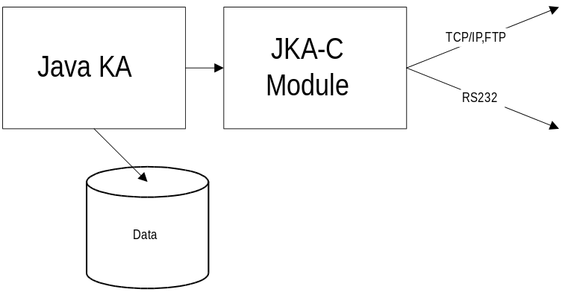

1. Message layout
The interface provided by JKA-C supports the following messages:

1. Admit
1a. Update personal liquid requirements
2. Transfer
3. Discharge
4. Solid food diet prescription
5. Billing

1.1 Admit - ADT Message
The ADM message is to be sent from an administrative system to JKA.

Name | Offset | Length | Mandatory | Remarks
Transmitter ID. | 1 | 4 | Y | Identification of the transmitting system.
Msg Type | 5 | 4 | Y | “ADM “
Patient ID | 9 | 12 | Y | prefixed with zeroes (1)
Patient Name | 21 | 34 | Y | format: “Lastname, initials”
DOB | 56 | 8 | N | Example: 19650228
Patiënt PhoneNbr | 64 | 24 | N | Example: +123 (0)456 789 0123 (2)
Patient Location | 88 | 10 | N
Admitting Phys. | 98 | 30 | N | format: “Lastname, initials”
Phys. PhoneNbr | 128 | 24 |  | Example: +123 (0)456 789 0123 (2)
Blood type | 152 | 3 | Y | O +,O -,A -,A +,B +,B -,AB-,AB+ (3)
Liquid of choice | 155 | 1 | Y | C/T/W/N (Coffee, Tea, Water, Not specified)
Milk | 156 | 1 | N | N/B/L/U (No milk/a Bit/Lots/Unknown)
Sugar | 157 | 1 | N | number of lumps (4)
Liters_a_day | 158 | 5 | N | numeric: between 0.000 and 5.000
Notes:
1. Use Patiënt ID 0 if Patiënt ID unknown. Patiënt name must be specified if the Patiënt Id equals 0.
2. “<+>country_code<space>city/region<space>numb.” Fill character = space.
3. 1st 2 characters = blood type, 3rd character = + (rhesus positive) or - (rhesus negative). Filled with spaces if bloodtype or rhesus factor unknown.
4. Valid only if liquid of choice contains either C or T.

1.1a Update Personal Liquid Requirements - UDP Message
Messages of type UPD can be sent by third party systems whenever the patiënt changes his or her preferred liquid. The layout of the UPD message is equal to the layout of the ADM message. The fields Patiënt Location, Blood Type and Patiënt name are not mandatory when sending an UPD message.

4. Solid food prescription - SFP Message
The SFP message can be sent from a dietician’s system to JKA. The message either contains the addition or the removal of a diet element (represented by its solid food reference number) from/to the diet of the patient. Note that a patients’ diet can consist of a single diet identifying code, it may also consist of a considerable number of diet elements. In the latter case multiple SFP messages should be sent.

Name | Offset | Length | Mandatory | Remarks
Transmitter ID. | 1 | 4 | Y | Identification of the transmitting system.
Msg Type | 5 | 4 | Y | “SFP“
Patient ID | 9 | 12 | Y | prefixed with zeroes
Prescribing Dietician. | 21 | 30 | Y | format: “Lastname, initials”
Dietician PhoneNbr | 51 | 24 | N | Example: +123 (0)456 789 0123
Action indicator | 75 | 1 | Y | Add/Remove/remove all eXisting items (1)
Solid food reference | 76 | 10 | Y | Diet, Supplement or Food Item Code
Service period | 86 | 1 | N | Identifies the applicable service periods (2)
Textual instruction | 87 | 50 | N | Specific dietary instructions
Notes: (1) A for Add, R for Remove, X for resetting current diet.
(2) 1 = breakfast, 2 = mid-morning snack, 3 = lunch, 4 = mid-afternoon snack,
5 = dinner, 6 = bedtime snack. “ “ (space) = all service periods.

4.1 Solid food query – SFQ Message
The SFQ message can be used to query the dietary items stored in the JKA database that have been prescribed by the dietician and have been sent to JKA by means of SFP-messages.

Name | Offset | Length | Mandatory | Remarks
Transmitter ID. | 1 | 4 | Y | Identification of the transmitting system.
Msg Type | 5 | 4 | Y | “SFQ“
Patient ID | 9 | 12 | Y | prefixed with zeroes

4.2 Solid food diet – SFD Message
Whenever the JKA application receives a SFQ message, it generates one or more SFD (Solid food diet) messages. If more the patient’s diet is comprised of more than 3 dietary items, a sequence of SFD messages will be sent. Each message contains a maximum of 3 dietary items.

Name | Offset | Length | Mandatory | Remarks
Transmitter ID. | 1 | 4 | Y | Identification of the transmitting system.
Msg Type | 5 | 4 | Y | “SFD“
Patient ID | 9 | 12 | Y | prefixed with zeroes
Number of SFR’s | 21 | 4 | Y | prefixed with zeroes (2)
Solid food reference | 25 | 10 | Y | Numeric, max. 10 digits (1)
Service period | 35 | 1 | N | Identifies the applicable service periods
Solid food reference | 36 | 10 | N | Numeric, max. 10 digits (1)
Service period | 46 | 1 | N | Identifies the applicable service periods
Solid food reference | 47 | 10 | N | Numeric, max. 10 digits (1)
Service period | 57 | 1 | N | Identifies the applicable service periods
Notes: (1) Contains 0 if not specified.
- Contains the (remaining) number of solid food references that is stored in this (& following) messages. If equal to 0, no dietary information is available associated with the requested Patient ID.

